## Man overboard procedure

List what is available on board and where

Reduction

* Stay in cockpit when possible
* Keep center of gravity low
* Go on high side of the boat (if heeling)
* Use
  + First or second reef
  + Short handed
  + Poor visibility (i.e. night, fog)
  + Faster boats
* New, high quality boat shoes only worn on board, non-skid

Challenges

* Cold water shock
  + Gasp reflex (wear life jacket)
    - Sequence
      * Gasp reflex
      * Uncontrollable inhale water
      * Uncontrolled breathing time
  + Swim failure
  + Hyperthermia
* Finding the victim
* Get floatation device to them
* Haul back into the vessel

Be a good victim

* Stay afloat
  + Wear life jacket
* Pull arms in and reduce heat loss
* Keep clothes on – (keeps heat in)
* May need shoes
  + If swept to shore
  + Get back on board
* Maintain composure
  + Male yourself more visible
  + Signaling devices
  + Whistle
  + Reduce heat loss
    - Pull arms in and legs up
    - Do not swim
    - Close foul weather gear enclosures
  + Be on leeward side
* Crew on vessel shout that they see them and assure victim

Initial response

* 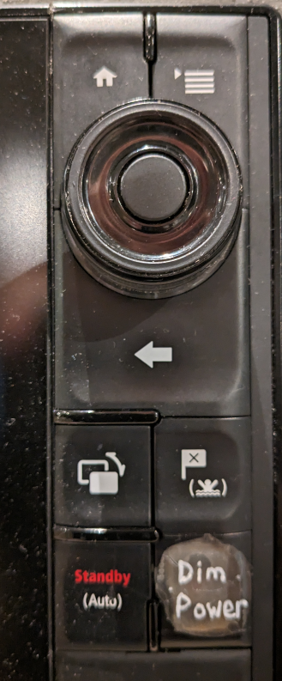Throw floatation when someone goes overboard
  + Person can swim to it
  + Marks location
* Have someone on board be a pointer who tracks person in the water
* Store position in GPS
  + Should be activated within 10 seconds
  + Press Man overboard button on the chartplotter
  + Distress button on VHF radio (if available)
    - Lift cover
    - DSC Digital Selective Calling)
* Consider how current affects position
* Broadcast a mayday
  + Cancel mayday once person is on board
* Person in command
  + Procedure to use
  + Engine or sails
* Methods
  + Heave to
  + Figure 8
  + 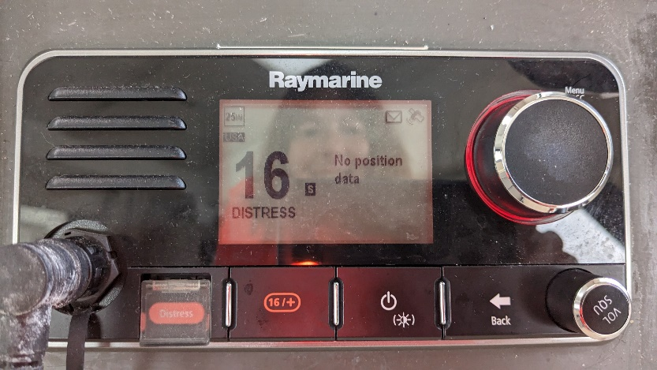With spinnaker

Equipment

* Life jacket
* Boarding ladder
  + Fastest in calm water
  + Hyperthermia – people loose dexterity in their hands
  + In rough water, stern ladder looks like cheese grater
* Horseshoe
  + Has buoyancy
  + Not attached to boat
* Man 8
  + Gear with horseshoe, light (like the dan buoy)
  + Life sling
    - Make sure it is already attached to vessel
* Throwable life ring
  + Not attached to vessel
* Standard cushion
  + Colors life blue may not be visible
* SOS Dan buoy
* Throw rope heaving life

Reboarding victim

* Boarding ladder
  + Calm waters
  + Warm waters
* Brute force
  + Have healthy, strong crew
* Lifesling hoisting
  + Direct hoist method (extra halyard where line can be down to water line)
  + Attach lifesling lifting sling shackles attached to any halyard
    - Raise fiddle block up at least 10 feet
* Elevator method

Beacons and Signaling

* Fanny pack
  + Marine whistle
  + LED flashlight
    - Bright
    - Waterproof
  + Laser flare
    - Positive – good for long distance
    - Con – can not shine at aircraft (put crew’s eyes at risk)
  + Signal mirror
    - Aircraft can see from 10-15 miles away
    - Viewing screen (i.e. red dot)
    - Plastic, durable, cheap
  + Strobe light
    - Steady LED
    - Water activated
  + Personal locator beacon (PLB)
    - Transmits for up to 24 hours
    - Goes directly to the Coast Guard
    - Bad since it does not signal to your vessel
  + AIS transmitted
    - Deploys automatically
    - Attached to blow tube on life jacket
    - Show up on chart plotters as MOB
  + AIS and MMSI of vessel

Conclusion

* Preventable through good habits and standard operating procedures
* Structured commands
* Devices to locate victim
* Floatation